Eyes turn into skin: How inflammation can change the fate of cells

December 21, 2015 Ecole Polytechnique Fédérale de Lausanne

Chronic inflammation can cause regenerating cells to grow into new, aberrant types; this is called metaplasia, and is a disorder linked to prolonged inflammation. A new study highlights a new concept of chronic inflammation and could lead to better treatments.
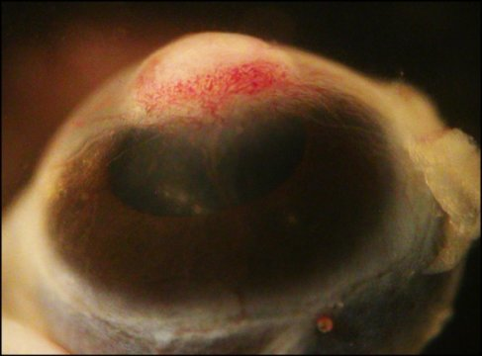
Macroscopic image showing skin forming in the cornea of a mouse following chronic inflammation.
EPFL scientists have found that chronic inflammation can cause regenerating cells to grow into new, aberrant types; this is called metaplasia, and is a disorder linked to prolonged inflammation. The study highlights a new concept of chronic inflammation and could lead to better treatments.
Chronic inflammation turns the immune system on for prolonged periods of time. As a result, it underlies many disorders that are associated with chronic inflammation, including cancer and abnormal wound healing. EPFL scientists have now discovered an additional component: chronic inflammation can cause cells to actually change type -- here, eye cells turned into skin. The study is published in Nature Cell Biology.
Many tissues contain a reserve of stem cells that help them heal and self-renew after injury or inflammation. Wanting to understand what happens under chronic inflammation conditions, a team of researchers led by Freddy Radtke at EPFL's Swiss Institute for Experimental Cancer Research (ISREC) studied stem cells in the corneas of mice. To do this, they used methods that simulate chronic inflammation, and analyzed the data with techniques that light up specific cells with fluorescent stains.
The scientists found that in the cornea, the environment of stem cells changed -- specifically, it became stiffer. The reason for this is both the presence of immune cells but also an increase in a substance that helps cells stick to each other and form structures and organs.
Eye cells become skin cells
The corneal stem cells, like many other cells, have sensors that measure the stiffness of surrounding tissues and allow the cells to adapt accordingly. In short, if stiffness changes, the cells react. In the cornea, the researchers found that the cell environment became so stiff that the stem cells began to turn on wrong differentiation programs: the "software" package that tells a stem cell what cell to turn into.
As a result of bad programming, the stem cells proliferated and made skin instead of cornea, causing the mice to go blind. In humans, this kind of abnormal change in the nature of a tissue is called "metaplasia," and is associated with chronic inflammation. "Our study demonstrates an important mechanism by which chronic inflammation induces abnormal stem cell behavior," says Freddy Radtke. "This is relevant to a variety of diseases associated with chronic inflammation, including cancer, and could yield new therapeutic targets."
Story Source:
The above post is reprinted from materials provided by Ecole Polytechnique Fédérale de Lausanne. Note: Materials may be edited for content and length.
Journal Reference:
- Craig S. Nowell, Pascal D. Odermatt, Luca Azzolin, Sylke Hohnel, Erwin F. Wagner, Georg E. Fantner, Matthias P. Lutolf, Yann Barrandon, Stefano Piccolo, Freddy Radtke. Chronic inflammation imposes aberrant cell fate in regenerating epithelia through mechanotransduction. Nature Cell Biology, 2015; DOI:10.1038/ncb3290

